

AMBUJ YADAV

ROLL NO: - 24/SCA/BCA/001

DATA STRUCTURE LAB

QUESTION -1: - Write a data structure program Find Largest Value of an Array. AMBUJ YADAV ROLL NO: - 24/SCA/BCA/001

ANS:-1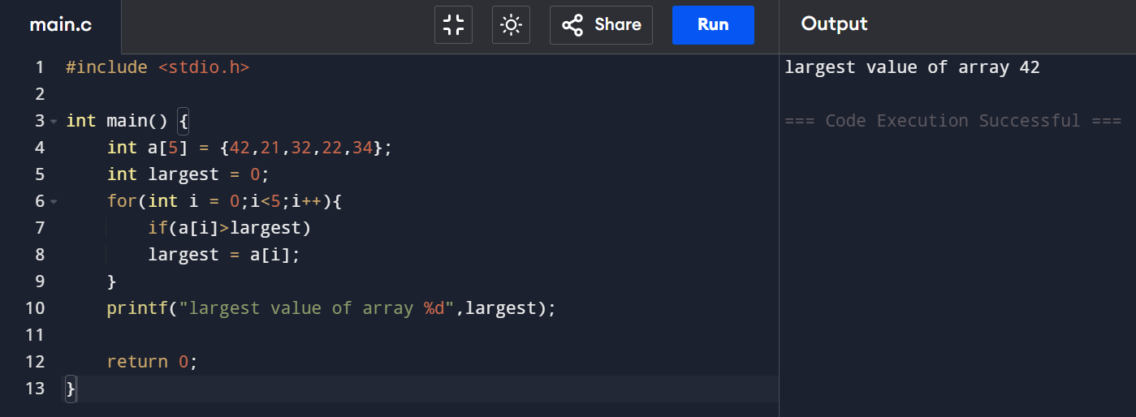

.

QUESTION -2: - Write a data structure program to find electricity bill. (Using if Statement) AMBUJ YADAV ROLL NO: - 24/SCA/BCA/001

ANS:-2 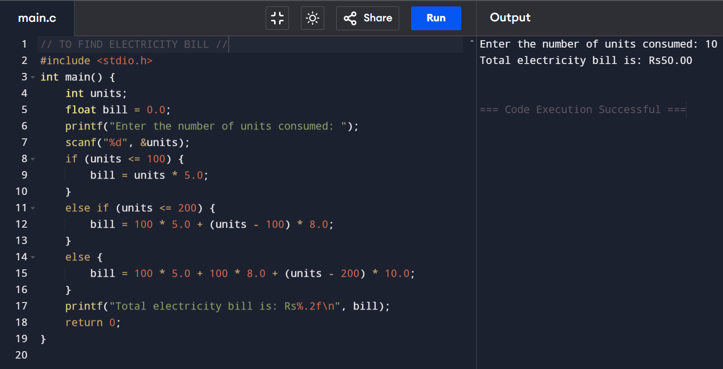

QUESTION -3: - Write a data structure program to Print Three Numbers where is smallest and largest. AMBUJ YADAV ROLL NO: - 24/SCA/BCA/001

ANS: - 3

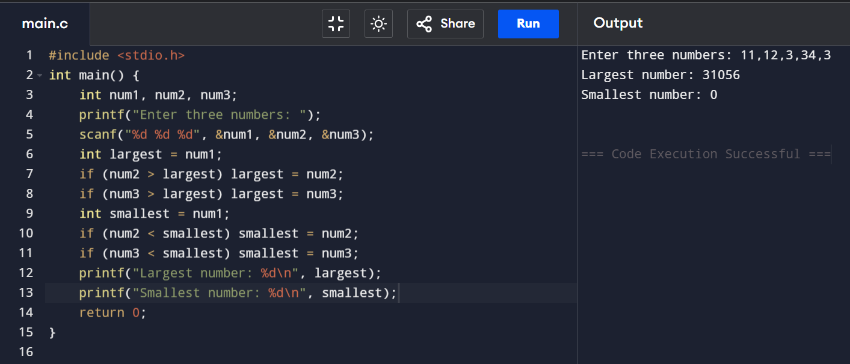

QUESTION -4: - Write a data structure program to declare an array and also find the values in it. AMBUJ YADAV ROLL NO: - 24/SCA/BCA/001

ANS:-4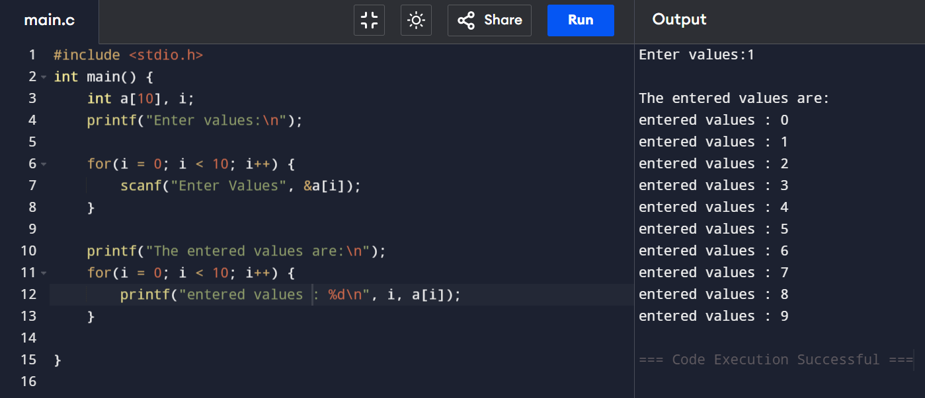

QUESTION -5: - Write a data structure program to insertion of an Array. AMBUJ YADAV ROLL NO: - 24/SCA/BCA/001

ANS:-5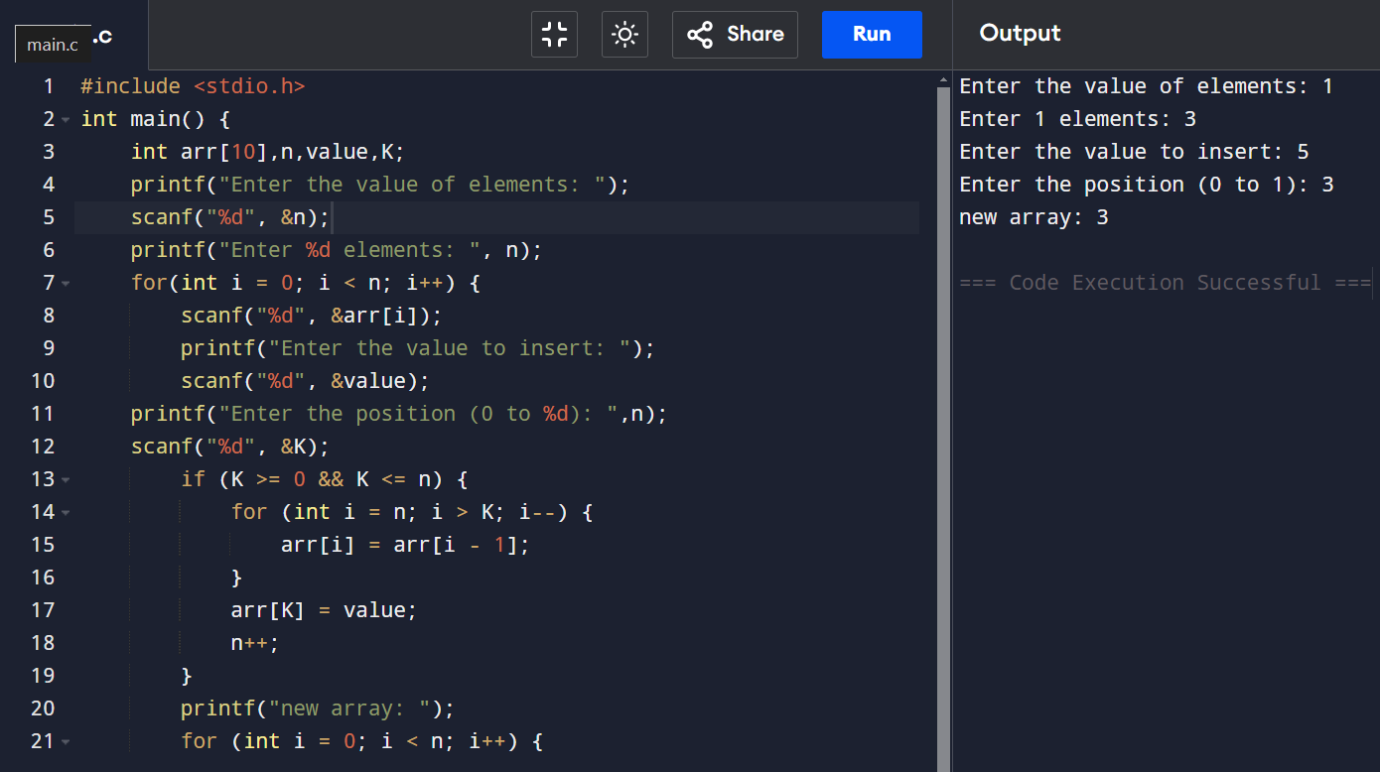

QUESTION -6:- Write a data structure program to enter the marks and find the sum and average.

AMBUJ YADAV ROLL NO: - 24/SCA/BCA/001

ANS6:-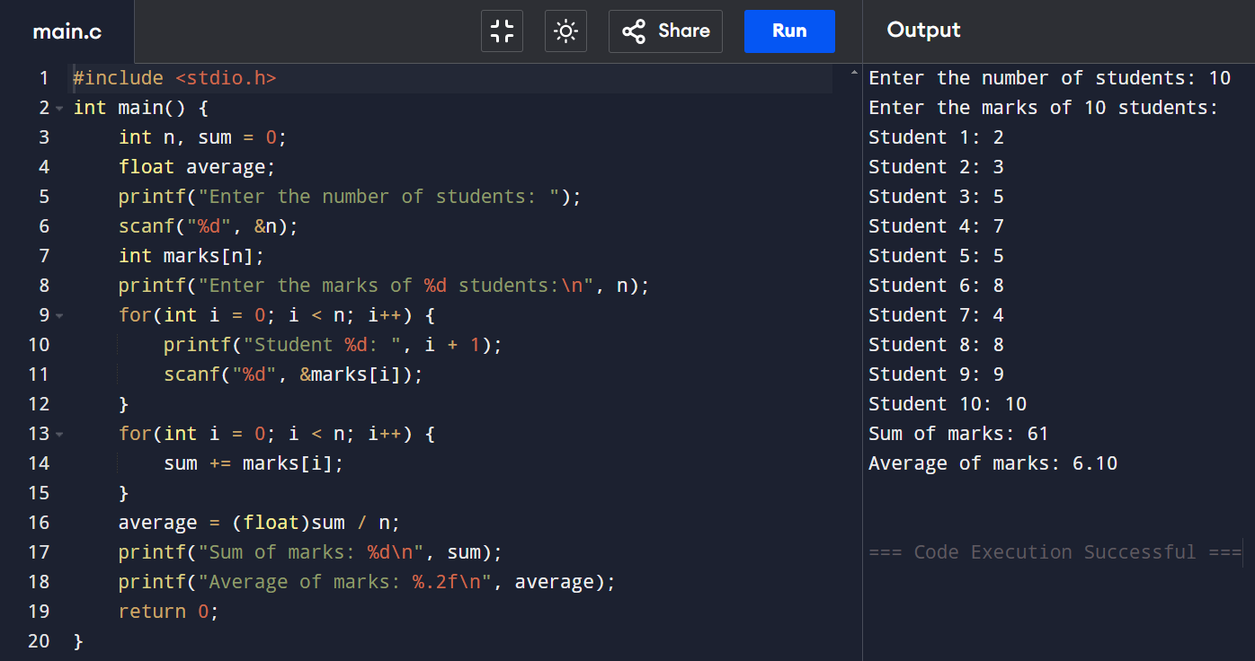

QUESTION -7:- Write a data structure program to enter the Traversed arrays elements. AMBUJ YADAV ROLL NO: - 24/SCA/BCA/001

ANS7:- 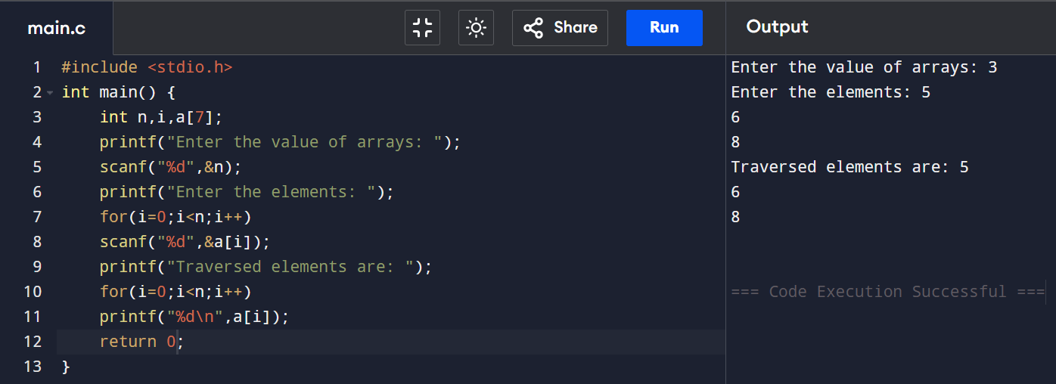

QUESTION -8:- Write a data structure program to delete an array. AMBUJ YADAV ROLL NO: - 24/SCA/BCA/001

ANS8:- 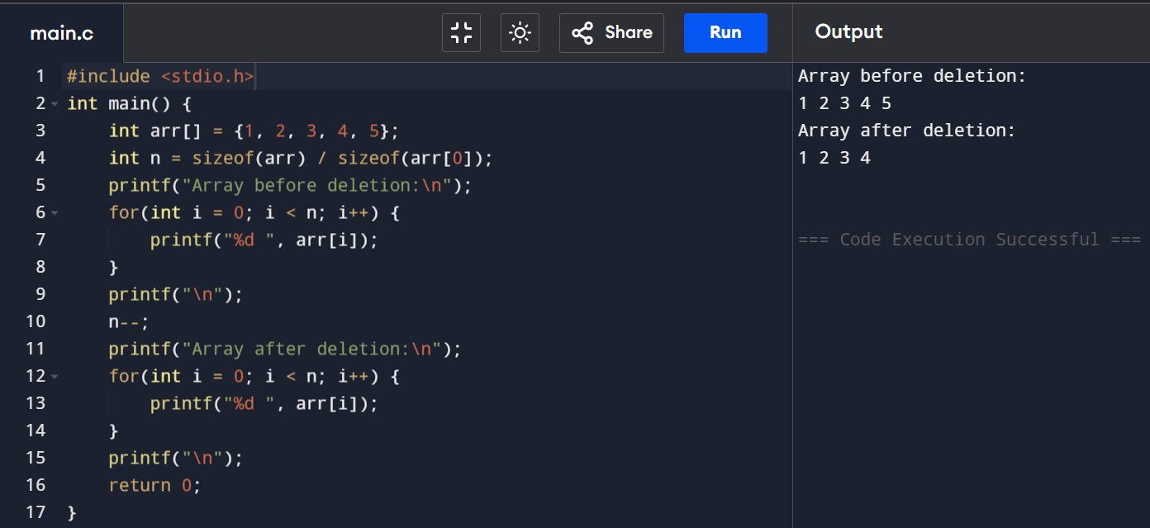

QUESTION -9:- Write a data structure program to find sum of n natural numbers. AMBUJ YADAV ROLL NO: - 24/SCA/BCA/001

ANS-9:- 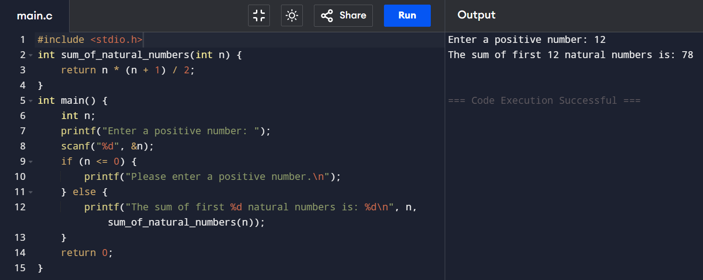

QUESTION -10:- Write a data structure program to find sum of n odd numbers. AMBUJ YADAV ROLL NO: - 24/SCA/BCA/001

ANS-10:- 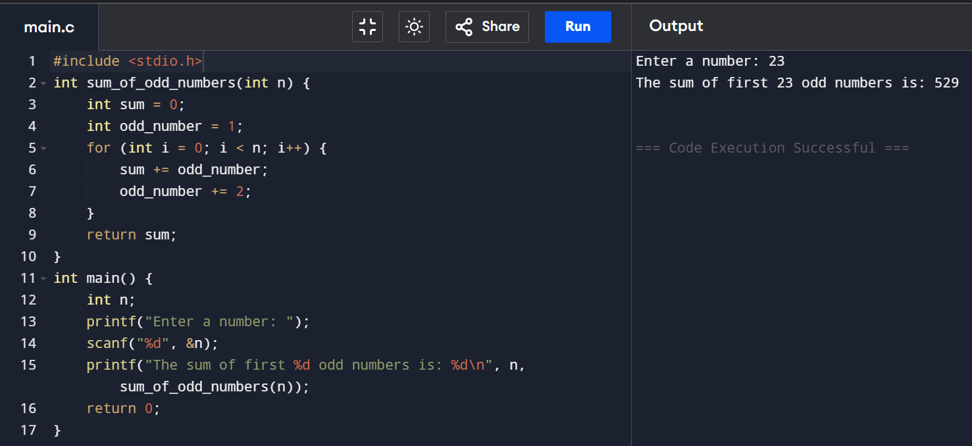

QUESTION -11:- Write a data structure program to find sum of n even numbers. AMBUJ YADAV ROLL NO: - 24/SCA/BCA/001

ANS-11:-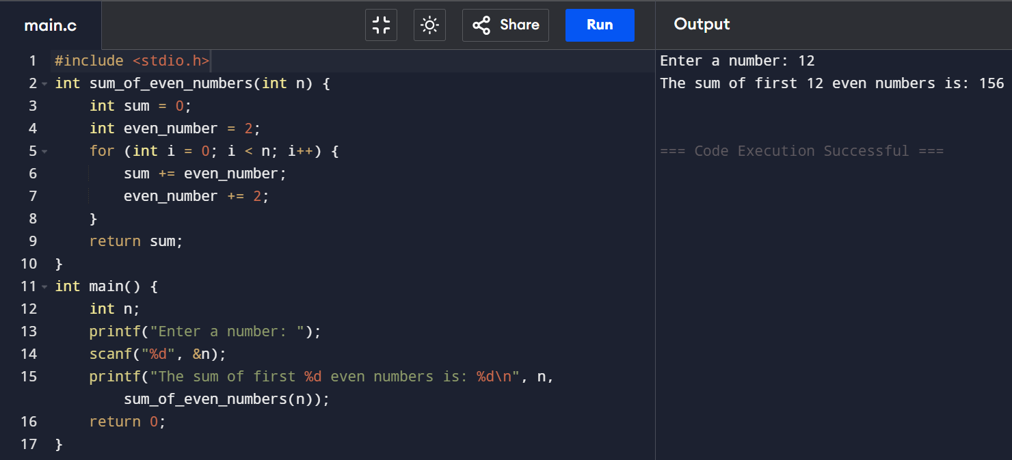

QUESTION -12:- Write a data structure program to find list which is divisible by 3 and 5. AMBUJ YADAV ROLL NO: - 24/SCA/BCA/001

ANS-12:-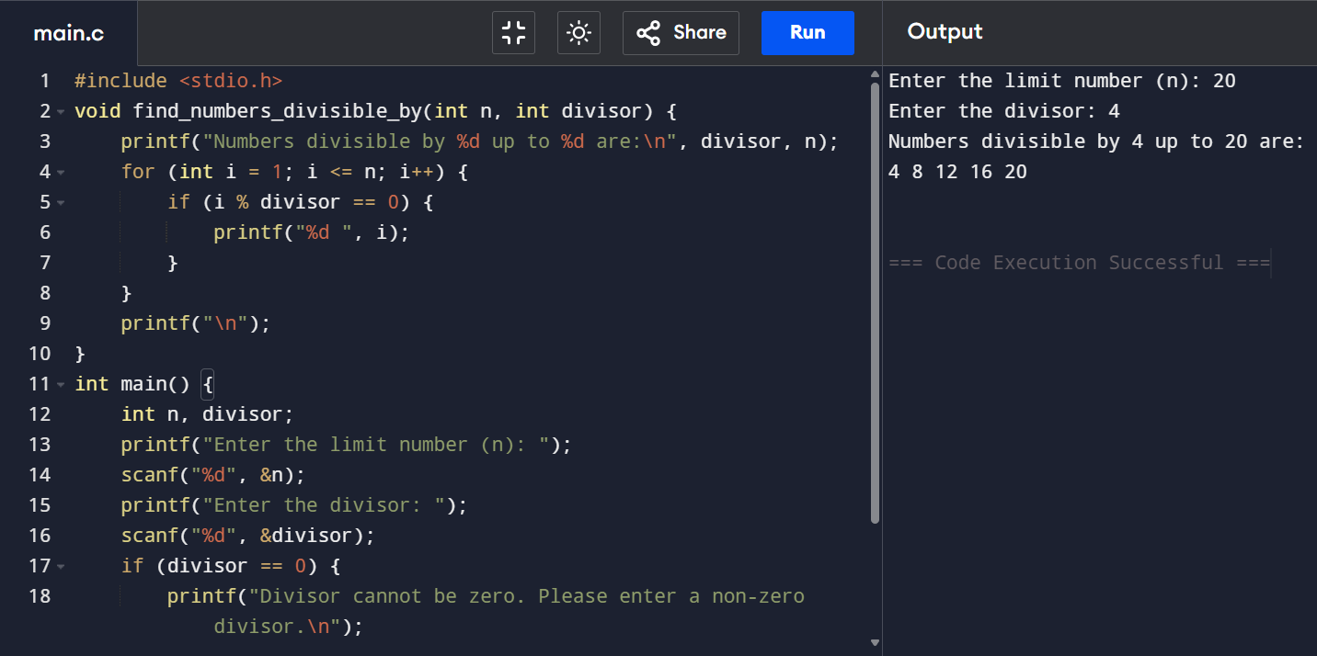

QUESTION -13:- Write a data structure program to Triversing of an Array. AMBUJ YADAV ROLL NO: - 24/SCA/BCA/001

ANS-13:- 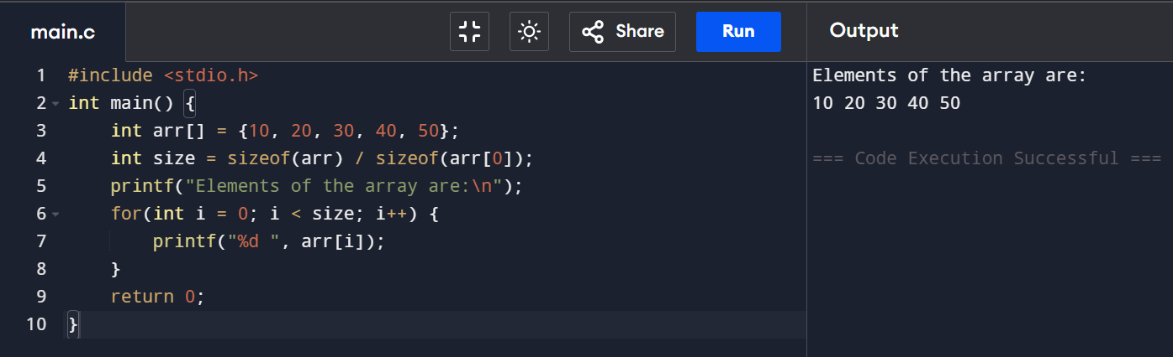

QUESTION -14:- Write a data structure program to stack using push and pop operations. AMBUJ YADAV ROLL NO: - 24/SCA/BCA/001

ANS:-14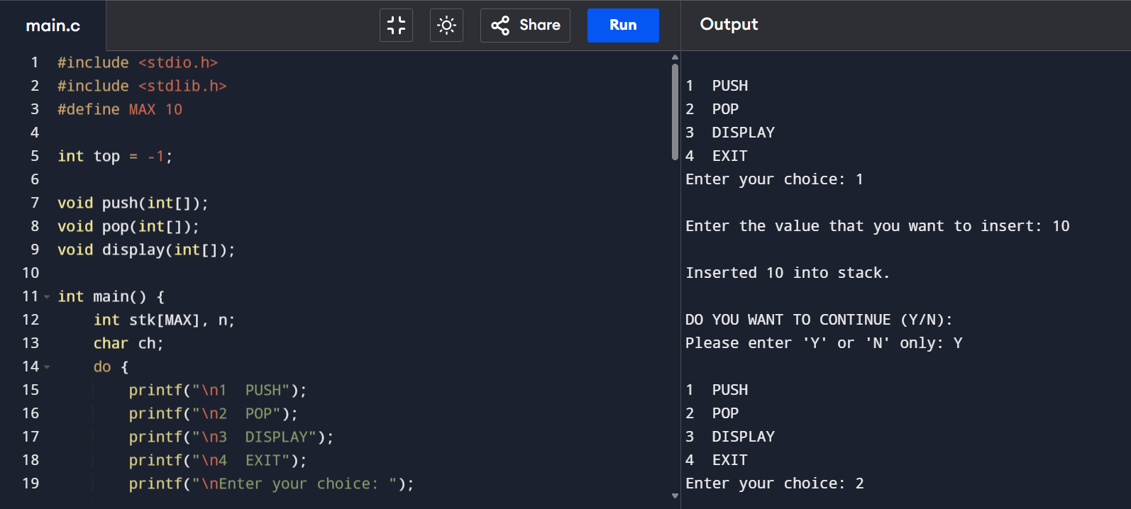

QUESTION -15:- Write a data structure program to stack using Queue and Deque operations. AMBUJ YADAV ROLL NO: - 24/SCA/BCA/001

ANS:-15 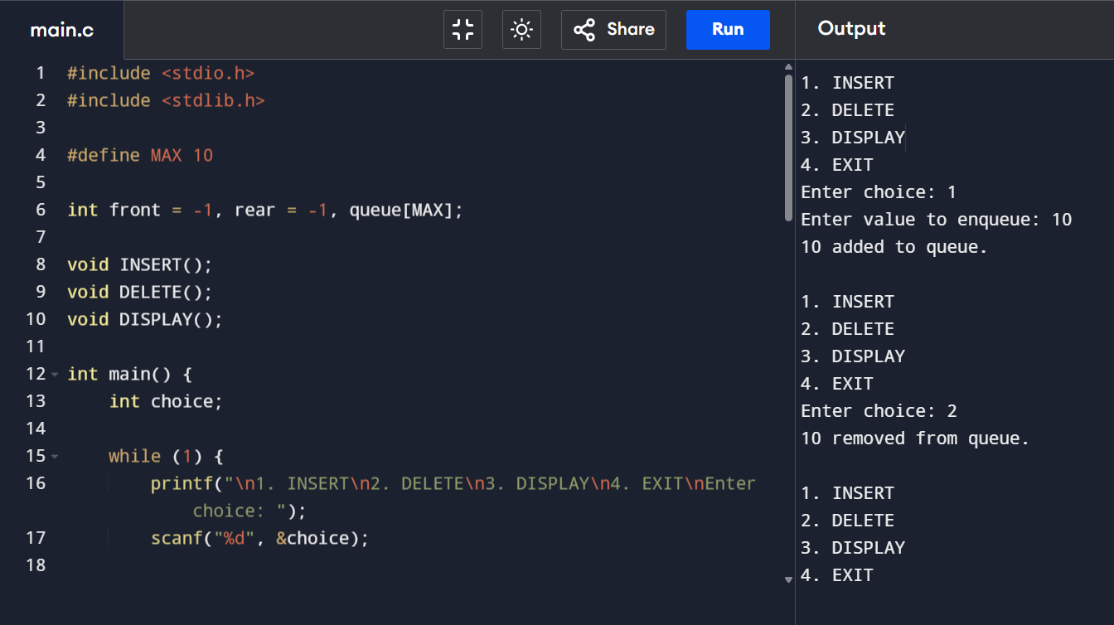

QUESTION -16:- Write a data structure program to implement linked list.

AMBUJ YADAV ROLL NO: - 24/SCA/BCA/001

ANS: - 16

